============================================================
FINAL CoAtNet EVALUATION METRICS
============================================================
Total Training Time : 00h 16m 59.18s
Overall Accuracy : 98.96% (0.9896)
Weighted Precision : 0.9898
Weighted Recall : 0.9896
Weighted F1 Score : 0.9896
Best Validation Acc : 98.96%

CLASS-WISE ACCURACY
----------------------------------------
Bacterial Leaf Blight : 97.64% (0.9764)
Brown Spot : 99.22% (0.9922)
Healthy Rice Leaf : 100.00% (1.0000)
Leaf Blast : 100.00% (1.0000)
Leaf scald : 97.62% (0.9762)
Sheath Blight : 99.21% (0.9921)

[✓] Saved metrics to: CoAtNet/coatnet_metrics.txt
[✓] Saved class-wise accuracy to: CoAtNet/coatnet_classwise_accuracy.txt
[✓] Saved classification report to: CoAtNet/coatnet_classification_report.txt
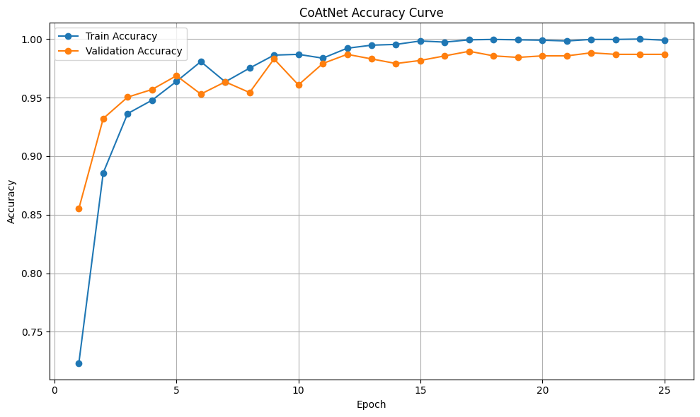
[✓] Saved accuracy graph to: CoAtNet/coatnet_accuracy.png
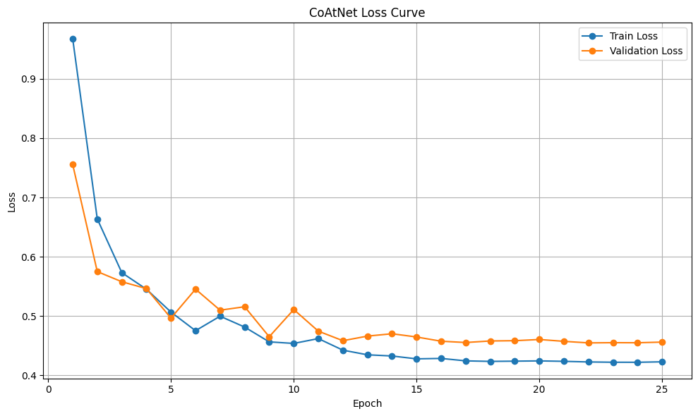
[✓] Saved loss graph to: CoAtNet/coatnet_loss.png
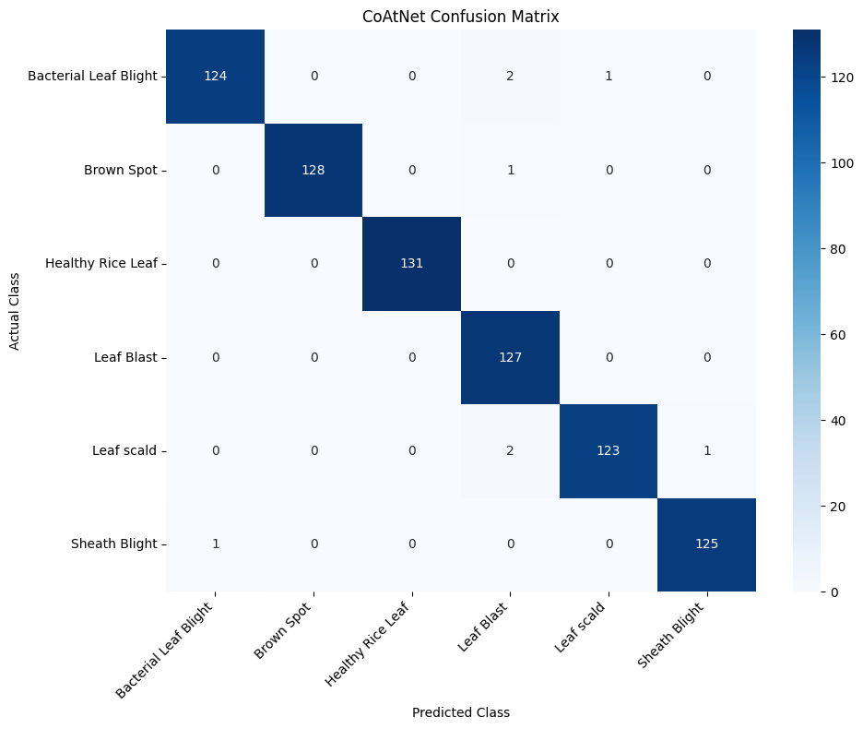
[✓] Saved confusion matrix to: CoAtNet/coatnet_confusion_matrix.png

[✓] Model saved to: CoAtNet/coatnet_rice_leaf_final.pth
[✓] PDF report saved to: CoAtNet/CoAtNet Output.pdf

============================================================
CoAtNet TRAINING COMPLETED SUCCESSFULLY
============================================================

Output files:
✓ CoAtNet/CoAtNet Output.pdf
✓ CoAtNet/coatnet_accuracy.png
✓ CoAtNet/coatnet_classification_report.txt
✓ CoAtNet/coatnet_classwise_accuracy.txt
✓ CoAtNet/coatnet_confusion_matrix.png
✓ CoAtNet/coatnet_loss.png
✓ CoAtNet/coatnet_metrics.txt
✓ CoAtNet/coatnet_rice_leaf_final.pth

Final Metrics:
Accuracy : 98.96%
Precision: 0.9898
Recall : 0.9896
F1 Score : 0.9896
Best Val : 98.96%

Done.

